Bài 1

a)

@prefix rdf: <http://www.w3.org/1999/02/22-rdf-syntax-ns#>.

@prefix ex: <http://example.com#>.

ex:TRUONGCNTTTT rdf:address

[ex:Number "1";

ex:Street "Dai Co Viet";

ex:Distrist "Hai Ba Trung";

ex:City "Ha Noi"].

b)

@prefix rdf: <http://www.w3.org/1999/02/22-rdf-syntax-ns#>.

@prefix ex: <http://example.com#>.

<https://soict.hust.edu.vn/> rdf:type ex:Website.

ex:SOICT rdf:domain <https://soict.hust.edu.vn/>.

ex:SOICT rdf:type ex:University.

c)

@prefix rdf: <http://www.w3.org/1999/02/22-rdf-syntax-ns#>.

@prefix ex: <http://example.com#>.

ex:URI1 rdf:type ex:Course;

rdf:courseName "SemanticWeb";

rdf:courseLecturer "Hung";

rdf:lectureRoom "D7-302".

Bài 2

@prefix rdf: <http://www.w3.org/1999/02/22-rdf-syntax-ns#>.

@prefix dc: <https://www.dublincore.org/specifications/dublin-core/dcmi-terms/>.

@prefix ex: <http://example.com#>.

ex:doc1 dc:Creator "Minh".

ex:doc2 dc:Creator _:x.

ex:doc3 dc:Creator _:x.

ex:doc3 ex:confirm

[a rdf:Statement;

rdf:subject ex:doc1;

rdf:predicate dc:Publisher;

rdf:object "W3c"].

Bài 3

@prefix rdf: <http://www.w3.org/1999/02/22-rdf-syntax-ns#>.

@prefix rdfs:<http://www.w3.org/2000/01/rdf-schema#>.

@prefix ex: <http://example.com#>.

ex:URI1 rdf:type rdfs:Class.

ex:URI2 rdf:type rdfs:Class.

ex:URI3 rdf:type rdfs:Property.

ex:URI4 rdf:type ex:URI1.

ex:URI5 rdf:type ex:URI2.

ex:URI6 rdf:type ex:URI2.

ex:URI3 rdfs:domain ex:URI1.

ex:URI3 rdfs:range ex:URI3.

Bài 4

@prefix rdf: <http://www.w3.org/1999/02/22-rdf-syntax-ns#>.

@prefix foaf: <http://xmlns.com/foaf/0.1/>.

@prefix ex: <http://example.com#>.

ex:Georges rdf:type ex:Saint;

foaf:name "Georges";

foaf:defeated _:x.

_:x a ex:Dragon.

ex:Michael a ex:Saint;

a ex:Archangel;

foaf:name "Michael";

foaf:defeated ex:Satan.

ex:Satan foaf:name "Satan".

Bài 5

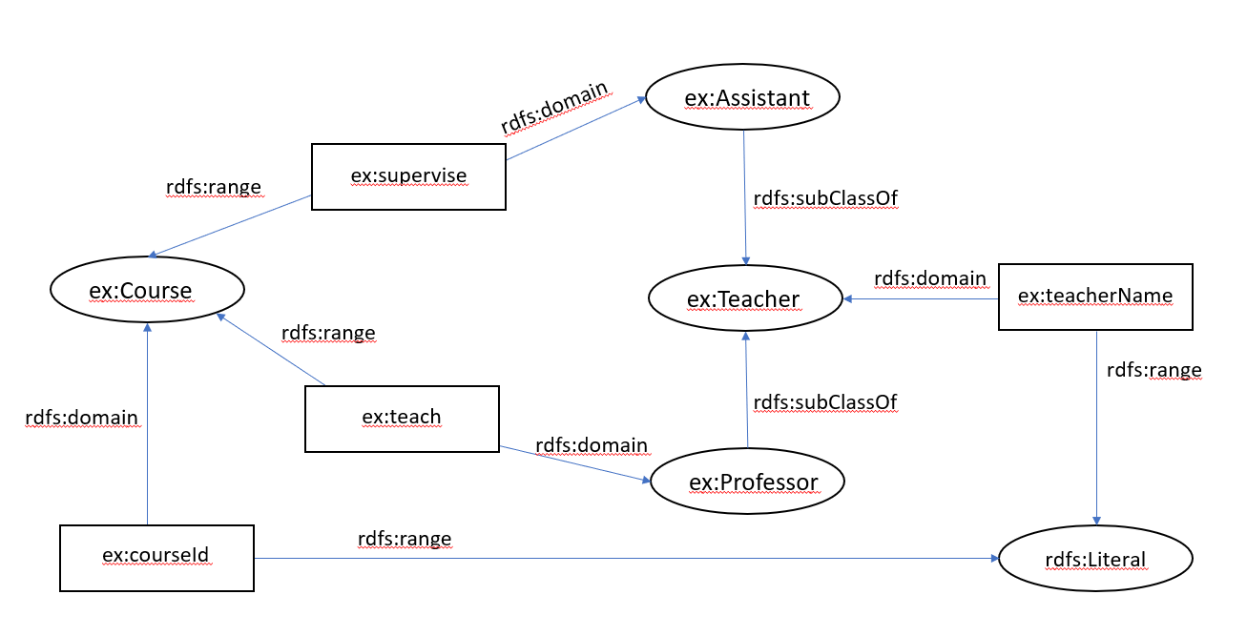

@prefix rdf: <http://www.w3.org/1999/02/22-rdf-syntax-ns#>.

@prefix rdfs:<http://www.w3.org/2000/01/rdf-schema#>.

@prefix ex: <http://example.com#>.

ex:Teacher rdf:type rdfs:Class.

ex:Course rdf:type rdfs:Class.

ex:teacherName rdfs:domain ex:Teacher;

rdfs:range rdfs:Literal.

ex:Professor rdfs:subClassOf ex:Teacher.

ex:Assistant rdfs:subClassOf ex:Teacher.

ex:supervise rdfs:domain ex:Assistant;

rdfs:range ex:Course.

ex:teach rdfs:domain ex:Professor;

rdfs:range ex:Course.

ex:courseId rdfs:domain ex:Course;

rdfs:range rdfs:Literal.

Bài 6

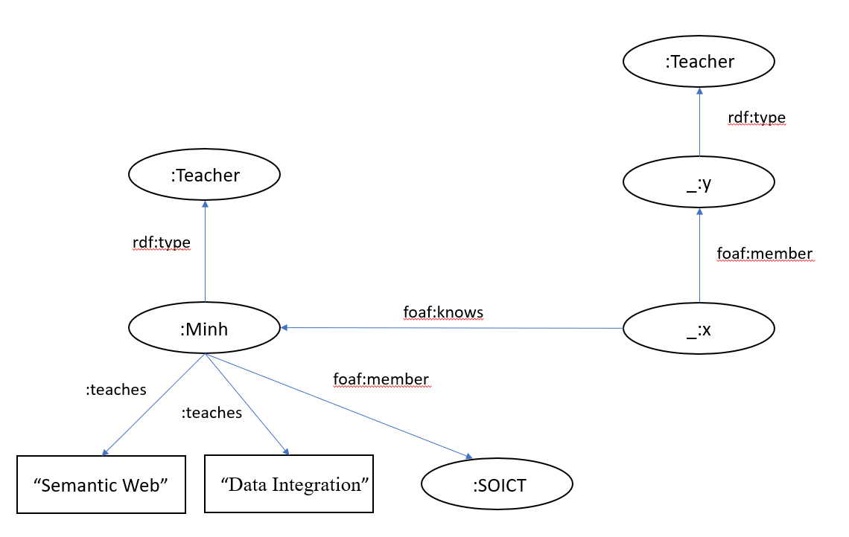

Bài 7

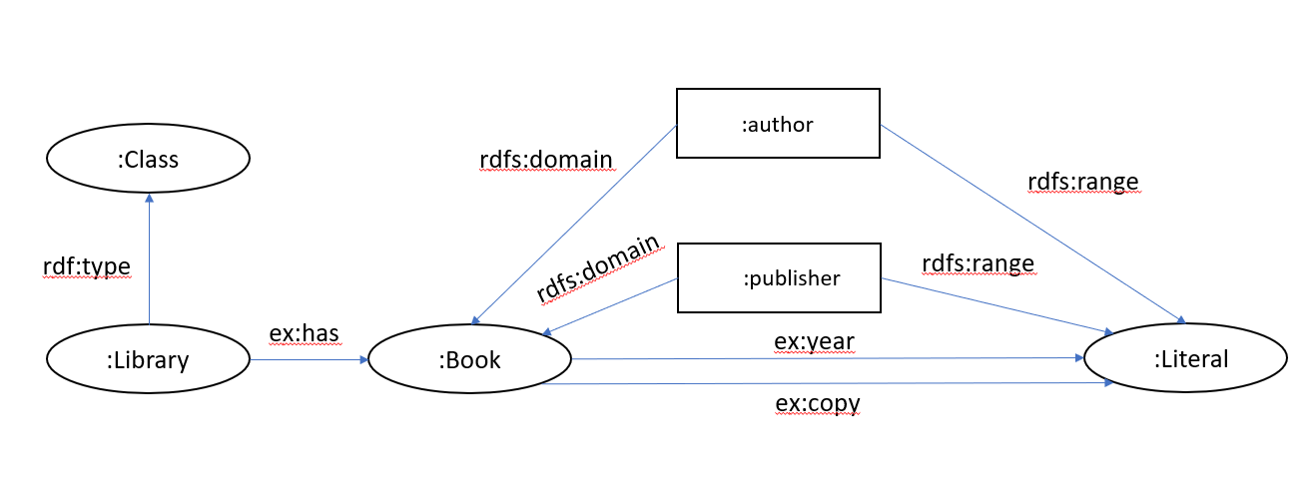

@prefix rdf: <http://www.w3.org/1999/02/22-rdf-syntax-ns#>.

@prefix rdfs:<http://www.w3.org/2000/01/rdf-schema#>.

@prefix ex: <http://example.com#>.

ex:Library rdf:type rdfs:Class;

ex:has ex:Book.

ex:Book ex:year rdfs:Literal;

ex:copy rdfs:Literal.

ex:author rdfs:domain ex:Book;

rdfs:range rdfs:Literal.

ex:publisher rdfs:domain ex:Book;

rdfs:range rdfs:Literal.